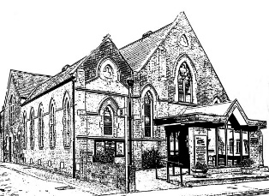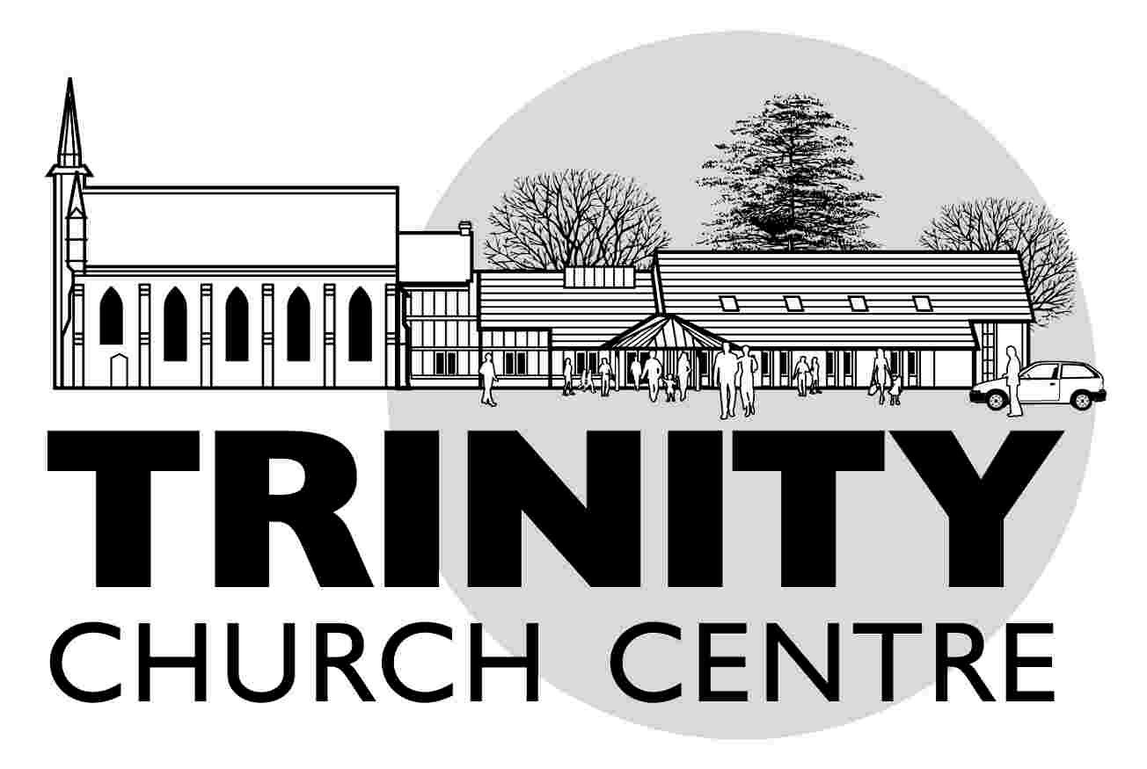**Wesley Centre**

**Conditions of Hire**

53 Christchurch Road

Ringwood

BH24 1DH

**Trinity United Church  
Official Conditions of Hire of Church Premises:**

* These premises are under the ownership of, and administered by, the Trustees of a Christian church and are used for Christian worship. We are pleased to allow our premises to be hired by a wide variety of community groups for many different purposes, as a Christian act of service and welcome to the whole community. However, we hold a specific conviction and policy that non-Christian worship would conflict with the primary intended use of the premises for the worship and service of God, according to Christian principles and practices. Therefore, the Trustees will not permit the hire of these premises for acts of worship which are not Christian in nature.
* The Hirer acknowledges that the above premises remain under the control of the Church and this hiring is not intended to confer exclusive possession upon me/us and that accordingly no tenancy of the premises is intended to be created.
* The Hirer is responsible for exercising care of and respect for the premises being used. Any damage, to the building or its contents, caused by the Hirer shall be deemed the responsibility of the Hirer and the cost of cleaning or repairs will be at the Hirer’s expense and paid for by the Hirer;
* The Hirer acknowledges that the Church gives no warranty that the premises are legally or physically fit for the purposes required by the Hirer and that the Church accepts no liability for any loss, damage to or injury to any person or property, or theft, liability or expense suffered by any person during or as a result of the Hirer's use of the Premises and that all persons using the Premises or bringing personal belongings to the Premises do so entirely at their own risk;
* The Hirer shall arrange appropriate insurance in respect of the potential liabilities referred to above and against any loss damage or injury to the Premises or any fittings or furniture belonging to the Church and shall indemnify the Church from and against all costs claims liabilities and expenses that may arise;
* The Hirer is expected to leave the venue used in the same condition in which it was found. All furniture and equipment is to be returned to its rightful place at the end of each booking.
* The Hirer ensures that no personally owned electrical equipment such as heaters, CD players, etc., are used on the premises unless they have a legal PAT certificate and without the permission of Trinity Centre management;

• The Hirer shall be responsible for securing all licences and permits required lawfully to use the Premises for the purposes intended and shall indemnify the Church in respect of any failure to secure such licences;

• The Church reserves the right to cancel any booking on giving not less than 24 hours’ notice (except in the event of emergencies when less notice may be given) and to cancel the booking at any time before or during the period of hire in the event of any breach of the Hirer's obligations;

* The Church reserves the right to review the fees payable periodically;
* Please note: It is the policy of the Methodist Church that no alcohol is allowed on the premises at Wesley Centre.

Trinity Centre 🞄 Christchurch Road 🞄 Ringwood 🞄 BH24 1DH 🞄 01425 461 440

contact@trinityringwood.co.uk 🞄 www.trinityringwood.co.uk